Clinical Guideline for:
Sedation in ICU

SUMMARY

This guideline describes the modality and expectations for the delivery, monitoring and cessation of sedation for patients on the intensive care unit (ICU).

CONTENTS

- Introduction
- Sedative drugs
- Monitoring and depth of sedation
- Sedation cessation

- INTRODUCTION
This guideline describes the initiation, monitoring, management and expectations for the sedation of critically ill patients in the Intensive Care Unit (ICU) of the East site (Wonford) in Royal Devon University Healthcare Foundation Trust. The scope of the document is intended to cover intensive care patients who require sedation for agitation, improvement of intervention tolerance and humane approach to intensive care.

This guideline aligns itself with the Faculty of Intensive Care Medicine (FICM) recommendation of GPICS 2.1 [1]. Sedation in the ICU is often required to improve compliance with intervention and decrease distress and agitation. However, deep levels of sedation for critically unwell patients can be associated to poorer outcomes such as increased mechanical ventilation time, increased ICU and hospital length of stay. It is therefore paramount to tailor the sedative approach to the patient’s needs and to ensure that levels of sedation are minimised [1].

Pain is common in ICU patients and should be addressed alongside the use of sedative agents. Optimising non-medication interventions such as careful positioning, enabling communication and treating discomfort can be valuable steps in ensuring patient’s safety without the use of sedation.

Governance and accountability
Patients receiving sedation are the responsibility of the consultant intensivist. Clear plans for levels of sedation should be recorded and communicated to the nursing staff looking after each sedated patient. Decisions about types of sedative agents, level of sedation and cessation of sedation are the responsibility of the most senior clinician and prescribing clinician, and should be reviewed on every senior ward round.

Compliance of guidelines
Regular audits will be performed to ensure current compliance to clinical guidelines. Educational and practical strategies will be put in place to ensure high compliance. Training to the multi-disciplinary team will be provided in the event of poor adherence.

- SEDATIVE DRUGS
The choice of sedative agent is dependent on the familiarity and experience of the clinician, the patient’s needs and local culture. The following list of drugs is not exhaustive and need to consider clinical prerogatives.

Separate clinical guidelines for each drug are available on the local hub and can be accessed for further information.

- Propofol
Propofol is considered as first-line choice for intravenous sedation. Due to its cardiovascular properties, propofol should be used by practitioners trained in airway management and respiratory support and with caution in unstable patients. Propofol maximum usual dosage by infusion is 4mg/kg/hr (actual body weight or adjusted body weight in obese patients [8]) to prevent accumulation and propofol-related Infusion syndrome. Propofol must NOT be used for sedation of children under the age of 16 years on ICU without consultant discussion. It should also be avoided in patients with a soya bean allergy.

See separate guideline for more information [2].

- Alfentanil / Remifentanil
Opioids are usually prescribed alongside propofol to facilitate ETT tolerance and ensure appropriate analgesia. Alfentanil is the first line opiate, however in certain cases, remifentanil can be recommended by the ICU consultant for its short acting period and metabolism independent from renal and liver function. It carries a high risk of causing apnoea and bradycardia. It should not be used without advanced respiratory monitoring. Opioid agents should be used by practitioners trained in airway management and respiratory support and with caution in unstable patients. Remifentail and Dexemedetomidine should not be used together due to the aforementioned side-effects.

See separate guideline for more information [3].

- Dexmedetomidine / Clonidine
Alpha2-agonists drugs may be used (but are not currently recommended) as first line sedation but are usually reserved for when sedation wean has been unsuccessful. They cause hypotension and bradycardia and are sedative and analgesic. They carry risk of cardio-vascular depression and patients should be closely monitored for signs of adverse effects such as compromising bradycardia and hypotension. They provide useful anxiolysis and may also be used in alcohol withdrawal syndromes.

See separate guideline for more information [4]

- Ketamine
Ketamine has become increasingly popular as a NMDA antagonist sedative agent due to its sympathomimetic properties. Ketamine also preserves airway reflexes contrary to other sedative agents. Ketamine infusions may be used for analgesia in certain patient’s group (e.g spine patients) but are not routine on the ICU. Ketamine also carries risk of hallucinations and dose-dependent dissociative state.

See separate guideline for more information [5].

- Benzodiazepine
Benzodiazepines are not recommended for continuous sedation as they have been linked with increased ICU-delirium incidence [4]. PRN boluses of benzodiazepines in specific contexts such as status epilepticus or alcohol withdrawal can be considered and remain at the discretion of the prescribing clinician.

- MONITORING AND DEPTH OF SEDATION
Light sedation

Recent research has shown that light sedation practice has a beneficial impact on mechanical ventilation time, length of stay in ICU and in hospital [1], as well as patient communication, interaction and participation in rehabilitation. Sedation target should encourage the use of light sedation defined by a score from -2 to 0 on the Richmond Agitation and Sedation Scale (RASS) (appendix 1). Apart from specific circumstances highlighted in appendix 2, light sedation should be targeted and assessed in a continuous manner. If deep sedation is preferred (-3 to -5 on RASS) due to the patient’s condition, it is the responsibility of the prescribing clinician to clearly set sedation targets and expectations.

Monitoring

All patients receiving sedation should have their level of sedation assessed and recorded hourly as per national guidance [1]. RASS is the preferred sedation scale and should be completed and recorded hourly onto the patient’s record. Levels of sedation are expected to be reviewed by the treating team and titrated accordingly.

- SEDATION CESSATION
Daily sedation hold is recommended in order to evaluate the cognition and state of sedation of patients and to limit accumulation of sedative agents and are linked to improved patient outcomes [7]. Daily sedation holds should be performed unless contraindicated. If concern exists about discomfort or pain, analgesia should be optimised beforehand. Sedation hold decision is usually discussed at morning ward rounds but can be instigated earlier if agreed with the on-call consultant.

If the patient experiences severe autonomic disturbances (hypertension, tachycardia) and/or there are risks for staff or their safety, a sedation hold should be abandoned and sedation resumed. Sedation is expected to be restarted at half dose and titrated in accordance to agreed sedation target.

- REFERENCES
[1] Faculty of Intensive Care Medicine (FICM) (2019) Guidelines for the Provision of
Intensive care Services edition 2. Available at:
https://www.ficm.ac.uk/sites/ficm/files/documents/2021-10/gpics-v2.pdf

[2] Propofol for sedation on ICU (2018) Royal Devon University Healthcare NHS Foundation trust.

- Use of Remifentanil sedation in ICU (2023) Royal Devon University Healthcare NHS Foundation trust.

- Protocol for: Dexmedetomidine infusion (2019) Royal Devon University Healthcare NHS Foundation trust.

[5] Clinical Guideline for: The Administration of Ketamine Infusion for Pain Management (2021) Royal Devon University Healthcare NHS Foundation Trust.

[6] Wang H, Wang C, Wang Y et al. Sedative drugs used for mechanically ventilated patients in intensive care units: a systematic review and network meta-analysis. Current Medical Research and Opinion. 2018; 25 Sep. Doi: 10.1080/03007995.2018.1509573.

- Graham, N. D., Graham, I. D., Vanderspank-Wright, B., Varin, M. D., Nadalin Penno, L., Fergusson, D. A. & Squires, J. E. (2023) 'A systematic review and critical appraisal of guidelines and their recommendations for sedation interruptions in adult mechanically ventilated patients'. Australian Critical Care, 36 (5), pp. 889-901.

[8] https://www.sobauk.co.uk/_files/ugd/373d41_eebe369c3c6b4021bff6f3da059aa796.pdf

- APPENDICES
Appendix 1: Richmond Agitation Sedation Scale

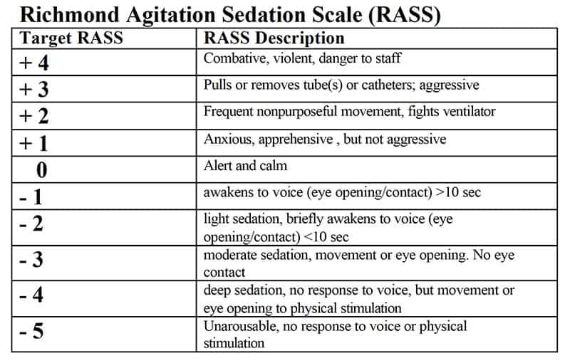

Appendix 2: Light sedation decision tool

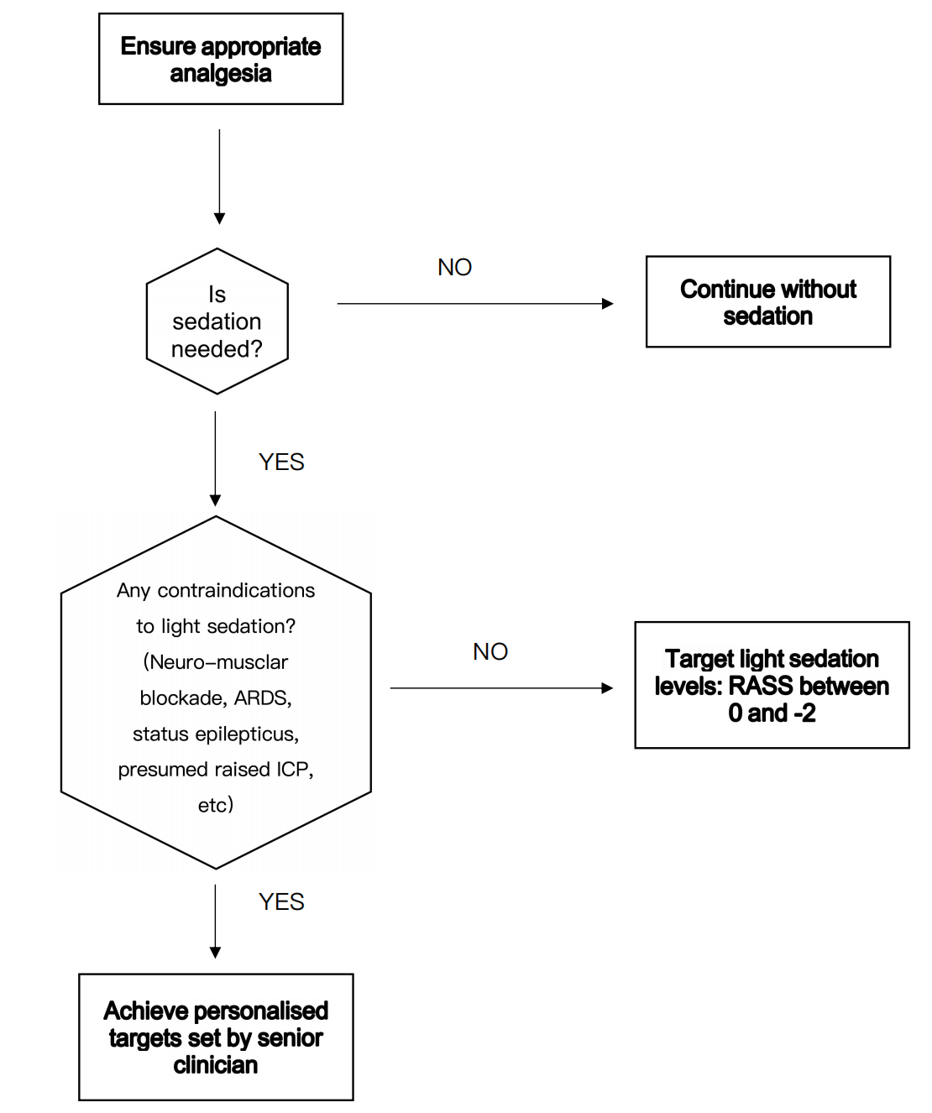

PUBLICATION DETAILS
Authors of Clinical Guideline | Mark Davidson (ICM Consultant)  Romain Lefebvre (ACCP)
Division/Department responsible for Clinical Guideline | Surgical Services/ Intensive Care Unit
Contact details | x2424
Version number | 1.1
Replaces version number
Date written | 14/11/2024
Approving body and date approved | ICU Governance Group: xx/xx/xx
Review date | 20-07-2029
Expiry date | 20-01-2030
Date document becomes live | 03-04-2025

